VALUES TO BE WEIGHTED FOR ONE YEAR PREDICTION MODEL

* One-year spending
* Total Logins in year
* Power / Points
* # of friends => this is sort of encapsulated in our other variables (power/points, total logins)

Nothing is really strongly correlated with our LT spending but total logins is best indicator which makes sense. The more they log in the more they are likely hooked and willing to spend. Logins, power, friends are all relatively correlated.

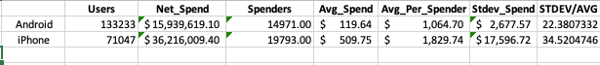

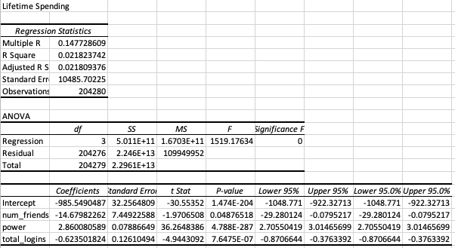

These four are a really bad model. 2% R squared.

WHAT PEOPLE NORMALLY BASE IT OFF OF: Retention, Monetization, Cost